Patient Information
Cell changes on the neck of the womb (cervical dysplasia)
Conisation

Tissue samples (biopsies) from the neck of the womb (cervix) have confirmed the presence of cell changes. If they are not treated, cell changes may, over time, develop into cancer. We therefore recommend a small operation (conisation) to remove these abnormalities.

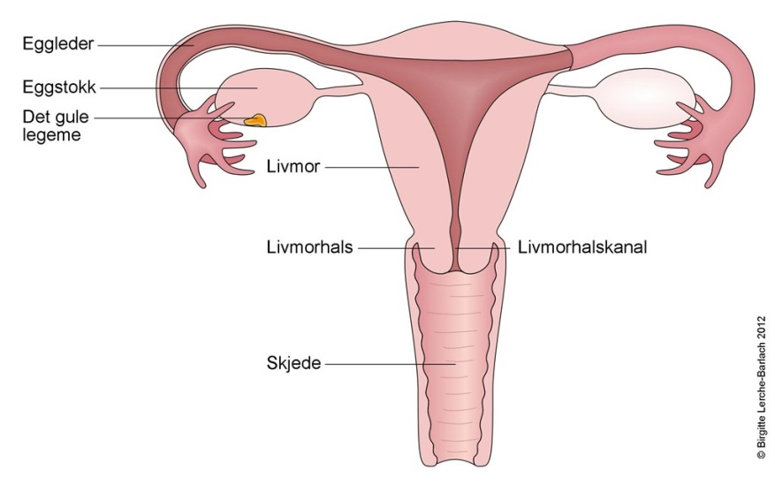
Illustrasjonen er hentet fra Norsk elektronisk legehåndbok(NEL)
Treatment (conisation)
You must not apply body lotion on the day of the procedure, as it can lead to an equipment malfunction during the operation.
During conisation, the area where the cell changes are situated at the tip of the womb neck (cervix) is removed with an electromagnetic coil. This is usually carried our under local anaesthetic. Preparations for the procedure take a little time, but the operation itself takes only a few minutes.
Complications
1)Early:
Bleeding: There is a risk of more bleeding than is normally expected, both during the operation, and over the following days. To prevent this, it may sometimes be necessary to insert a special tampon into the vagina after the procedure. You will then be instructed to remove this yourself in the evening, or the following morning. If you experience persistent bleeding, similar to a heavy period, contact the duty Gynaecologist. The risk of bleeding is greatest on the days immediately after the procedure.
Infection: It is normal to experience some pain after the operation, when the anaesthetic has worn off. If the pain gets worse, or you develop a fever, contact the duty Gynaecologist
2)Later:
As a rule, conisation has little impact on subsequent pregnancies. If a large part of the womb neck (cervix) has been removed there is a certain risk for premature birth, or late term miscarriage. The cervix, may, in rare cases, become too narrow, which can lead to increased menstrual pain.
After the operation
Some bleeding after the operation is normal, and it takes 3-6 weeks for the wound on the cervix to heal. During this time, you should expect an increase in bloody discharge. Intercourse, use of tampons, bathing, and significant physical effort are not recommended during this time. You will normally be granted a few days sick leave.
The tissue that has been removed will be sent for analysis (histology). You will be followed up according to specific guidelines, with follow-up cell analyses (pap smears), and an HPV (human papilloma virus) test, depending on what kind of cell changes have been found. Both you and your family doctor (GP)/Gynaecologist will be informed of the test results and the type of follow up.
Some times the follow-up will be at the hospital, and in rare cases, when cancer has been detected in the sample, further tests will be carried out.

Link:
http://www.kreftregisteret.no/no/Forebyggende/Masseundersokelsen-mot-livmorhalskreft

Important telephone numbers:
Gynaecology outpatient clinic: 51 51 93 85
Gynaecology wards 4AC: 51 51 82 92

Welcome to the women's clinic
Kvinneklinikken SUS, januar 2015
www.sus.no/kvinneklinkken
Stavanger University Hospital

