Patient information
Prolapse operations

A prolapse can mean that the front wall of the vagina pulls the bladder downwards (cystocele); similarly, the back wall can pull the rectum/anal canal down (rectocele). A downward sag/prolapse of the posterior pelvic cavity can also occur (enterocele), or sagging of the womb itself. A combination of these conditions is often present
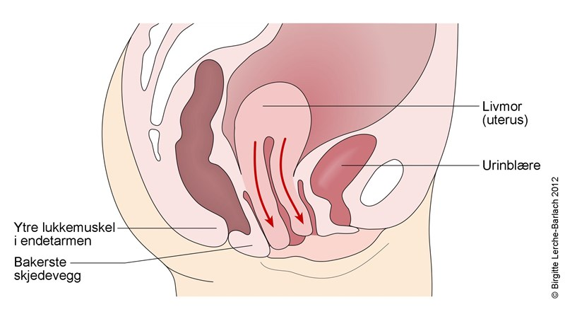
The cervix has sunk down so that it is all the way out in the vaginal opening

Livmoren er sunket ned slik at livmorhalsen er helt ute i skjedeåpningen

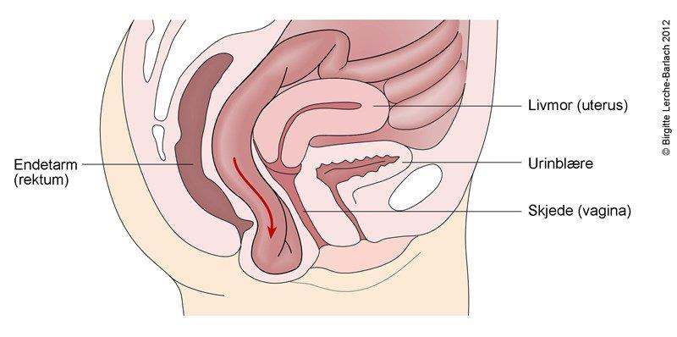
Enterocele, i.e a part of the gut presses down (red arrow) between the vagina and rectum.

The illustrations above are from the Norwegian electronic doctors' manual www.nel.no
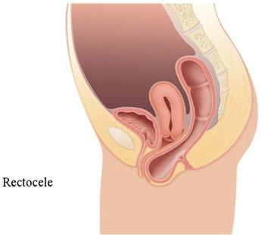
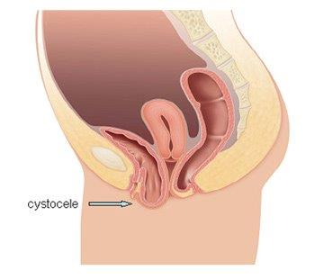

The illustration above is from www.familjeliv.se The illustration above is from www.gopixic.com
There are various surgical methods; most of them are carried out via the vagina. If the whole womb, or top of the vagina has sunk down following earlier removal of the womb, then keyhole surgery may be an option. In this case, the vagina is lifted up internally and fixed with a band. The doctor will explain which method is most suitable for you. These conditions are not dangerous and are very common. An operation is only recommended if troublesome symptoms have arisen such as a "bulge" in the vaginal opening, problems emptying the bladder and gut, or involuntary passing of air via the vagina. For some, treatment with a ring/diaphragm may be an alternative during the wait for surgery.
The doctor will inform you of the findings during surgery, and what has been done, either on the day of the operation or the day after.

Before the operation
You have been informed about the operation during the preliminary examination /"journal recording". If you are taking medication, it is important that your medication list is updated
In order to reduce the risk of infection, it is important that you don't remove your pubic hair yourself before the operation. This will be done when you come to the ward on the day of your operation. You can borrow clippers, or receive help from our staff as needed.

Operation method/anaesthetic
You will have a general anaesthetic or possibly a spinal anaesthesia/block. If you have a spinal block, the urine catheter will remain in place until the anaesthetic has worn off
After the operation, you should normally get out of bed after a few hours to reduce the risk of blood clots/thrombosis.
Complications
There is a risk of complications during any operation, both during and after the operation. General anaesthetic and other forms of anaesthesia also involve a slight risk.
- Bleeding and infection can arise. It can sometimes be necessary to empty the bladder with a catheter every 3-6 hours for a shorter period. It may be uncomfortable to pass water for the first few days, and you should try to empty your bladder every 3-4hours. If you don't manage to pass water, or if you can only pass small quantities of urine, you must tell our staff.
- Blood clots can occur even though you receive blood-thinning medication.
After returning home
You should continue taking pain relief medication regularly for the first few days, even if you don't have a lot of pain. You can reduce the dose and take it as needed after a few days, when the pain lessens. Vaginal discharge and light bleeding are normal during the first weeks.
You can maintain normal activity at home, but you should not lift heavy items, do heavy work, or vigorous sports, for the first 4 weeks. Intercourse, bathing, and use of tampons should be delayed for 3-6 weeks. You will receive a sick note for 1-6 weeks after the operation, depending on what type of work you do, and what kind of operation has been carried out.
You should keep up your pelvic floor exercises: 3 x 10 squeezes, 2-3 times a week. This is to prevent a recurrence after this kind of surgery.
If you have a fever, a strong smelling discharge, increasing bleeding or pain, acute shortness of breath, or swollen legs, you should contact the department where you were treated:
DK Hillevåg
Contact us on tel.: 51 51 44 99. Open until 18:00 on weekdays. For contact after 17:00, or on weekends, contact the Gynaecological Ward 4AC on tel. no.:51 51 82 92

Welcome to the Women's Clinic

Stavanger University Hospital

Kvinneklinikken SUS, januar 2015
www.sus.no/kvinneklinkken
Kvinneklinikken SUS, januar 2015
www.sus.no/kvinneklinkken
Kvinneklinikken SUS, januar 2015
www.sus.no/kvinneklinkken
Kvinneklinikken SUS, januar 2015
www.sus.no/kvinneklinkken
Kvinneklinikken SUS, januar 2015
www.sus.no/kvinneklinkken

